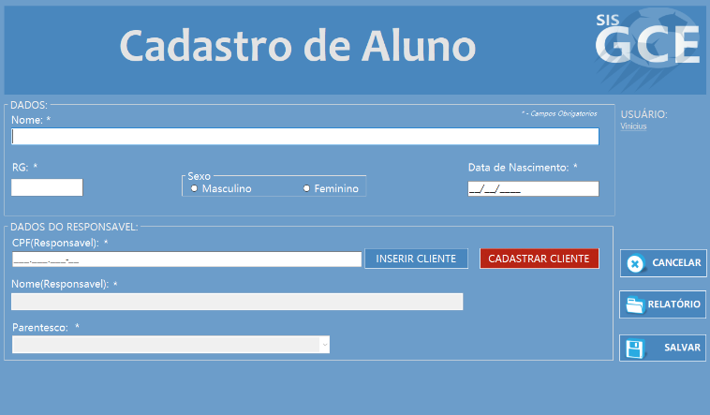

|  |  |  |  |  |
| --- | --- | --- | --- | --- |
| **CT NO.** | **PROPÓSITO** | | | |
| **01** | **VERIFICAR SE O ALUNO FOI ALTERADO** | | | |
| **PRÉ-CONDIÇÕES** | | | | |
| **NÃO TEM** | | | | |
| **ENTRADA1** | | **ENTRADA2** | **ENTRADA3** | **ENTRADA4** |
| **NOME** | | **RG** | **SEXO** | **DATA DE NASCIMENTO** |
| **ENTRADA5** | | **ENTRADA6** | **ENTRADA7** | **ENTRADA8** |
| **CPF(responsable)** | | **NOME(responsable)** | **PARENTESCO** | **BOTAO SALVAR** |
| **SAÍDAS ESPERADAS** | | | | |
| **ALUNO ALTERADO** | | | | |

|  |  |  |  |  |  |
| --- | --- | --- | --- | --- | --- |
| **TESTE No.** | **NOME** | **RG** | **SEXO** | **DATA DE NASCIMENTO** | **CPF**  **(RESPONSAVEL)** |
| **1** | **GUSTAVO MAX GOMEZ BEJAR** | **40.634.241-6** | **MASCULINO** | **01/03/2010** | **236.297.798-67** |
| **TESTE No.** | **NOME (RESPONSAVEL)** | **PARENTESCO** |  |  | **BOTAO** |
| **1** | **PORTELLA** | **RESPONSAVEL LEGAL** |  |  | **SALVAR** |
| **SAÍDA**  **ESPERADA** | | | | | |
| **ALUNO ALTERADO** | | | | | |

|  |  |  |  |  |  |
| --- | --- | --- | --- | --- | --- |
| **TESTE No.** | **NOME** | **RG** | **SEXO** | **DATA DE NASCIMENTO** | **CPF**  **(RESPONSAVEL)** |
| **2** | **GUSTAVO MAX GOMEZ BEJAR** | **40.634.241-6** | **MASCULINO** | **01/03/2008** | **236.297.798-67** |
| **TESTE No.** | **NOME (RESPONSAVEL)** | **PARENTESCO** |  |  | **BOTAO** |
| **2** | **PORTELLA** | **RESPONSAVEL LEGAL** |  |  | **SALVAR** |
| **SAÍDA**  **ESPERADA** | | | | | |
| **ALUNO ALTERADO** | | | | | |

|  |  |  |  |  |  |
| --- | --- | --- | --- | --- | --- |
| **TESTE No.** | **NOME** | **RG** | **SEXO** | **DATA DE NASCIMENTO** | **CPF**  **(RESPONSAVEL)** |
| **3** |  |  |  | **01/03/2008** | **236.297.798-67** |
| **TESTE No.** | **NOME (RESPONSAVEL)** | **PARENTESCO** |  |  | **BOTAO** |
| **3** | **PORTELLA** | **RESPONSAVEL LEGAL** |  |  | **SALVAR** |
| **SAÍDA**  **ESPERADA** | | | | | |
| **MENSAGEM DE ERRO** | | | | | |

|  |  |  |  |  |  |  |
| --- | --- | --- | --- | --- | --- | --- |
| **Aplicado em** | **Aplicado**  **por** | **Quantidade**  **de falhas** | **Depurado por** | **Reaplicado**  **em** | **Reaplicado**  **por** | **Quantidade**  **de falhas** |
| **01/11/2017** | **Luiz** | **1** | **Matheus** | **03/11/2017** | **Luiz** | **0** |